Experiment 11
Aim:
To implement Map Coloring using Constraint Satisfaction Problem (CSP) in Python, where adjacent regions are assigned different colors.
Algorithm:
- Start
- Define the map as a graph, where regions are nodes and adjacent regions are connected.
- Define the available colors as the domain.
- Select an uncolored region.
- Assign a color to the selected region.
- Check whether the assigned color conflicts with any adjacent region.
- If there is no conflict, move to the next uncolored region.
- If a conflict occurs, try another color.
- If no color is possible, backtrack to the previous region and change its color.
- Repeat until all regions are colored.
- Display the color assigned to each region.
- Stop.

Code:


Output:
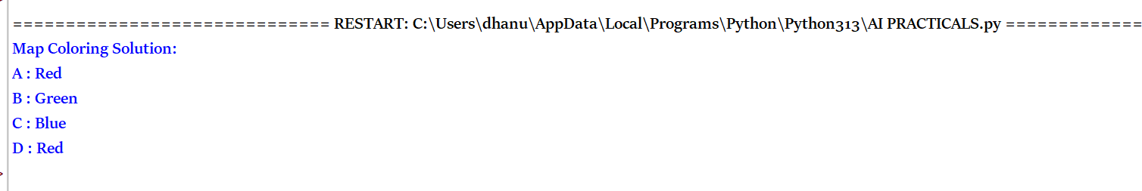
Result:
Thus the python program to implement Map Coloring using Constraint Satisfaction Problem (CSP) in Python, where adjacent regions are assigned different colors.

